**Programming Scratch the Cat**

this code

Scratch is a visual programming language developed by MIT and designed to introduce people to programming. The Scratch interface is composed of:

* A **stage** (top right-hand section) – where your sprites and backgrounds are hosted. It is here that you will see the effects of your code.
* A **scripts** column (narrow column down the left of the screen) – where you can navigate and find blocks of code that you want to use.
* A **code editor** (big grey area in the middle) – where you can add blocks of code together to perform actions on the objects on your stage.

***In Class Tasks/ Assignment***

Animate Scratch the Cat or other objects on the stage to do the following:

1. Reset Code – Before you make all the below stuff happen, it is a good idea to write some code that will return Scratch to his original spot facing in the same direction (looking right). Make sure this reset code happens whenever the flag icon is pressed.
2. When Scratch is pressed, starting from the centre position move the cat to the bottom left hand corner over a period of one second. Then rotate him so that he’s on all fours and proceed to animate him along the bottom of the screen until he reaches the end. Then rotate him once again and begin the process all over until he reaches all four corners of the stage. Finally return him to his original spot.

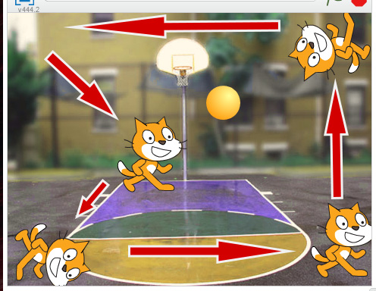

1. Change the background of the stage to be a basketball court.
2. When the Up keyboard key is pressed, increase the total size of the cat by about 15%. Every time you press the key this process should happen. Do the opposite when the down keyboard key is pressed. Make sure to update the reset code so that when you click on the cat he will return to normal size.
3. Add another sprite to the stage of a basketball. Create an animation when the space key is pressed where the cat will slam dunk the ball. As the cat releases the ball make it meow. When the ball hits the ground make it bounce up and down once.
4. Create reset code for the ball so that it returns to the correct position when it is clicked.

**Submitting:**

Take a screen shot of all your finished code (Shift + S + Windows Key). You may need more than one shot as each sprite requires its own code. Place them in a folder called ***your_first_and_last_name*** and place this folder in the folder marked **In Class Tasks HANDUP**. Make sure to label the images well.